EVENTS PAGE - http://www.initc3.org/events
The IC3 Blockchain Boot Camp – June 10-16, 2019

Cornell University
Ithaca, New York
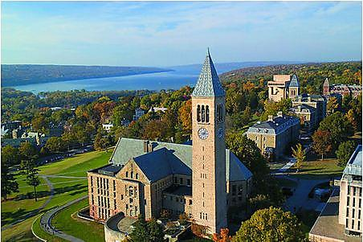

This is an immersive weeklong coding and learning experience in Cryptocurrencies, Blockchains and Smart Contracts with world-leading professors, open source architects, scientists, engineers, developers and students.

- Work on a dev team on a weeklong project, led by a blockchain expert.
- Attend daily presentations by smart contract and blockchain experts.

Who should attend? Experienced full-time blockchain architects, scientists, engineers, developers and students who want to learn, contribute and advance blockchain solutions.

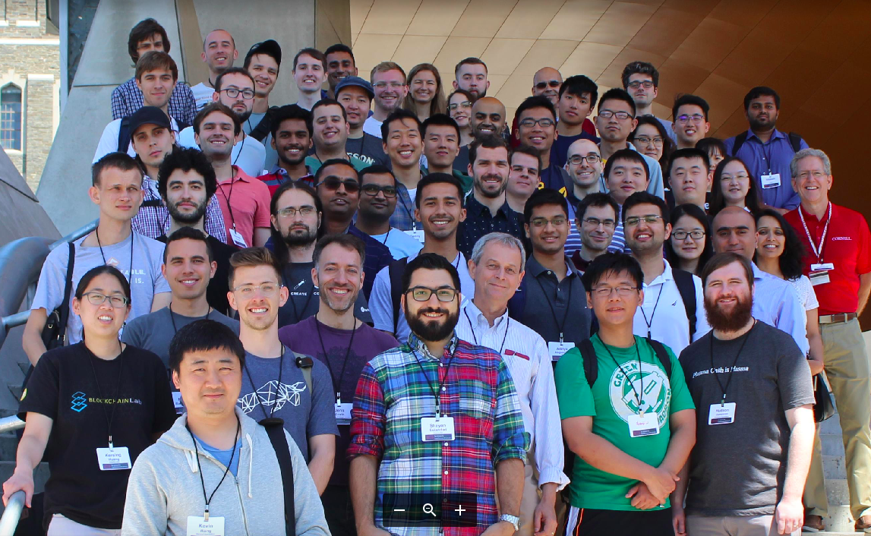Many of the participants at the 2018 Boot Camp gathered for a Group Photo prior to lunch on Day 1, on the steps of Gates Hall. See a summary of the 2018 Boot Camp here.

NOTABLE ATTENDEES

Join confirmed attendees this year including Vitalik Buterin, Hudson Jameson, Patrick McCorry, Andrew Miller, Emin Gün Sirer, Vlad Zamfir.

FUN ACTIVITIES

“Ithaca is Gorges”. To relax and clear our heads from time to time, we are planning periodic group excursions to local gorges, parks, lakes and points of interest.

REGISTRATION and SPONSORSHIP

STUDENTS: We are offering free access for a limited number of well-qualified full-time students enrolled at the IC3 campuses (Berkeley, Cornell, Cornell Tech, EPFL, ETH Zurich, UCL, UIUC, and the Technion); please apply here.

INDUSTRY/PROFESSIONAL PARTICIPANTS: All must be affiliated with an IC3 Member or a Boot Camp Donor (see details below).

BOOT CAMP DONOR – $12.5k US
- Donations support the Boot Camp, including scholarships for students attending for free, and on-going IC3 research.
- Includes Donor Brand logo on the IC3 website, and social media outreach.
- Includes Participation for one person for the full week of Hacking and Learning, plus participation in the Celebration Dinner on June 16.
- Includes Periodic Fun Activities.

IC3 MEMBERS
- Up to two employees of IC3 Members (see current list of members here) may participate free of charge.

All Industry/Professional participants, please apply here.

