IC3 2019 Winter Retreat

February 14-15, 2019 Congress Centre Kursaal Interlaken, Strandbadstrasse 44, 3800 Interlaken, Switzerland
IC3 faculty, students, sponsors and guests gather at IC3 Retreats to discuss the major technical challenges, issues and innovative solutions to widespread blockchain adoption. The 2019 Winter Retreat is in Switzerland with our IC3 colleagues from ETH Zurich and EPFL, as well as all other IC3 campuses (Cornell, Cornell Tech, UC Berkeley, UCL, UIUC, and the Technion).

The Retreat is on February 14-15, and co-located at Interlaken with the Swiss Blockchain Winter School on February 11-14, but is a totally separate event.
Registration for the Retreat is now closed. Please see the agenda below, and check back later for a summary of the event.
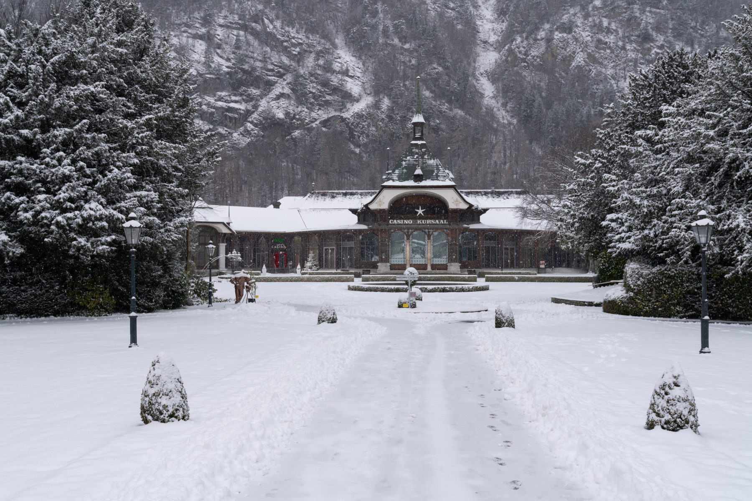
Congress Centre Kursaal Interlaken in Interlaken, Switzerland

IC3 Winter Retreat Agenda

Thursday  8:00 - 8:45 | Continental Breakfast
8:45 - 9:00 | Welcome - Ari Juels
9:00 - 10:00 | Blockchains at Scale I - 10 minute talks (8 minutes + QA)
Cristina Basescu - Low-latency and locality-preserving blockchains
Oded Naor - Teechain: A Secure Asynchronous Blockchain Payment Network
Patrick McCorry - Scaling Cryptocurrencies via State Channels
Mustafa Al-Bassam - Replay attacks against cross-shard communication protocols
Yan Ji - Amplification of selfish mining in fraud-proof based blockchains
10:00 - 10:30 | Break - 30 mins
10:30 - 11:10 | Blockchain at Scale II - 10 minute talks (8 minutes + QA)
Enis Ceyhun Alp - Heterogeneous sharded blockchain architecture
Karl Wust - ZLiTE: Lightweight Clients for Shielded Zcash Transactions using Trusted Execution
Sergi Delgado Segura - TxProbe: Discovering Bitcoin's Network Topology Using Orphan Transactions
Surya Bakshi - Erays: Reverse Engineering Ethereum's Opaque Smart Contracts
11:10 - 12:00 | Start-ups emerging from IC3 - 10 minute talks (8 minutes + QA)
Sergey Nazarov - Town Crier and Decentralised Oracles
Kevin Sekniqi - Avalanche
Noah Johnson - Oasis Labs
Soumya Basu - bloXroute
12:00 - 13:30 | Lunch
13:30 - 14:30 | Cryptography and Zero Knowledge - 10 minute talks (8 minutes + QA)
Jiaheng Zhang & Tiancheng - Faster zero-knowledge interactive proofs
Mary Maller - Improvements to Updatable CRS
Samarth Kulshreshtha - Scaling Asynchronous Multi-Party Computation: A Systems Perspective
Kevin Liao - A Calculus for Composable, Computational Cryptography
Tom Yurek - Client-efficient Asynchronous Verifiable Secret Sharing and Anonymous Broadcast
Krishna Deepak Maram Lun Wang - CHURP: CHUrn-Robust Proactive secret sharing
14:30 - 15:00 | Break - 30 minutes
15:00 - 15:45 | Panel: Too much infrastructure, not enough use-cases/usability studies?
15:45 - 17:00 | Industry and Community Use Cases - 10 minute talks (8 minutes + QA)
Dahlia Malkhi - Consensus Protocols
Angelo De Caro - Hyperledger Fabric Update
Michael Steiner - Intel and SGX Update
Jorge Cuellar - Siemens
Bob McElrath - Fidelity
Sascha Hanse - Aeternity
Nicola Greco - Protocol Labs
Simon Meier - Digital Asset Holdings
Christine Moy - JP Morgan
17:00 - 18:00 | Networking Reception
18:00 - | Dinner

Friday  7:15 - 8:00 | Continental Breakfast
8:00 – 9:00 | Proof-of-Personhood (Audience Participation Session)
9:00 - 10:00 | Consensus Protocols (Attacks, Defense, Models) - 10 minute talks (8 minutes + QA)
Kevin Negy & Sishan Long - Selfish Mining
Itay Tsabary - Gap game
Sanket Kanjalkar - “I Can’t Believe It’s Not Stakes”
Jian Liu - Saber: sharding by separating execution from consensus
Ethan Cecchetti - PIES and Proof of Replication
Phil Daian - The Dark Side of Blockchain - HFT, Bribery, Consensus Attacks, and More
10:00 - 10:30 | Break - 30 mins
10:30 - 11:40 | Reinforce Industrial use cases - 10 minute talks (8 minutes + QA)
Elefteris Kokoris-Kogias - Calypso on-chain secrets & policy enforcement
Tyler Kell - Lib-submarine
Kai Mast - Sharding blockchains
Alex Manuskin - Client Architecture
11:40 - 12:00 | Standup of New Ideas and Research Directions
12:00 - 12:15 | Closing Remarks

